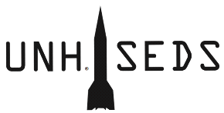

Dear SEDS USA,

Since SpaceVision 2018, all of us here at the University of New Hampshire have been hard at work in developing a hybrid engine using HTPB and Nitrous Oxide to compete in the Spaceport America Cup in June 2020. This two-year engineering project has split into two parts: the development of an optimized hybrid engine, and the building of an 8-inch diameter rocket to house the engine. The funds that we would receive from our application would directly help us in having the opportunity to do a second test with an optimized geometry to increase thrust and decrease weight.

Our group has grown tremendously, and our group had an amazing 16 students come to SpaceVision 2018, which was funded individually with no help from the school. The students in this group are passionate and are ready to pursue a deeper knowledge in amateur rocketry and space exploration. We hope to hear back from you soon and hope you consider us for financial assistance in our engineering projects. We are excited for the future of this organization, and see all of you at SpaceVision 2019 at ASU!

Charlie

Nitschelm

Thomas Collins

Ross

Thyne

**The Board of UNH SEDS**

Silas

Johnson

Carly

Benik